**PROJECT DOCUMENTATION**

|  |  |
| --- | --- |
| NM ID | NM2023TMID09736 |
| PROJECT TITLE | How to create a reel design using canva |
| DATE | 20-10-2023 |

Step-1 Create a Brand Name

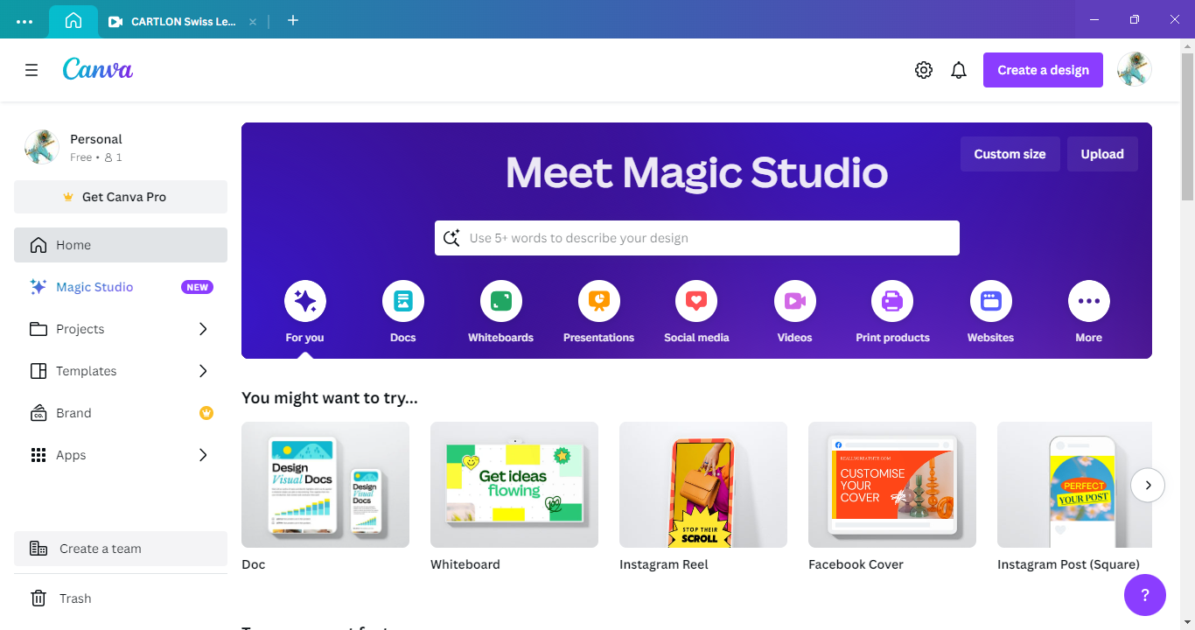



Step-2 Create a category

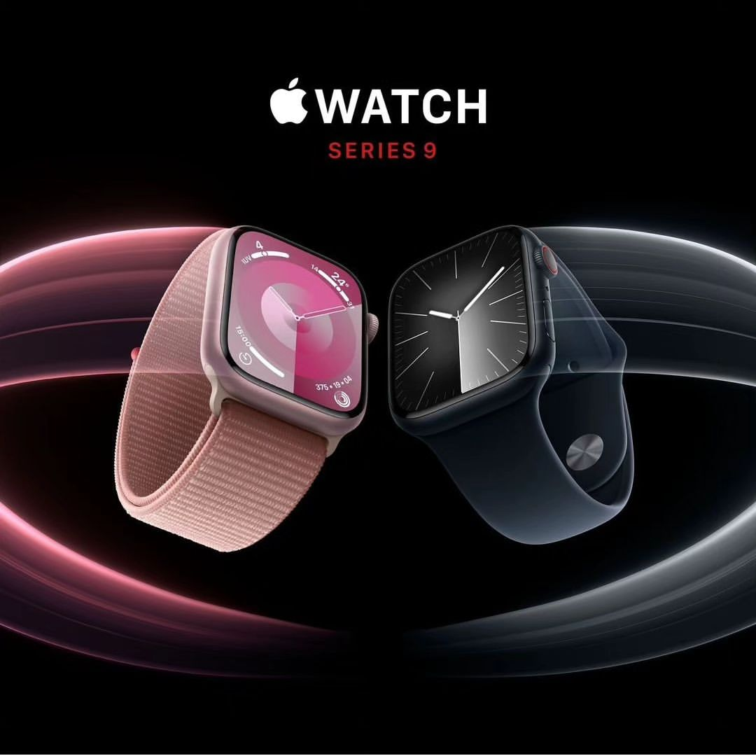

Step-3 Create an E-mail account for your Brand

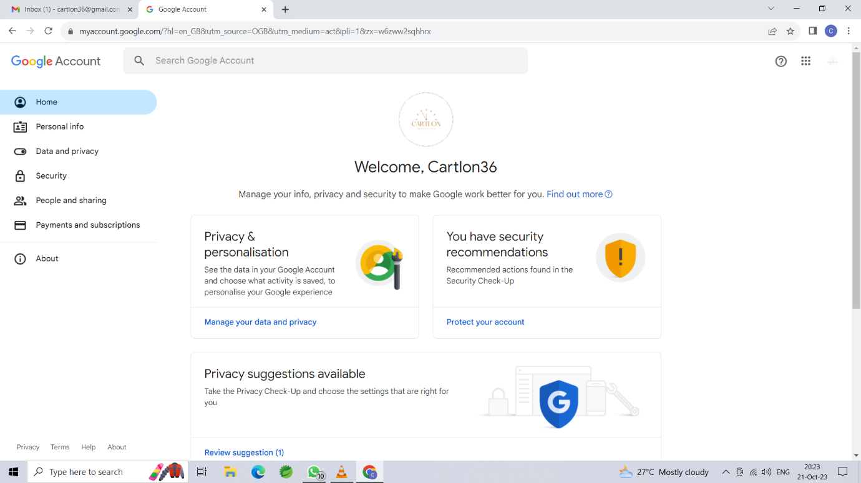

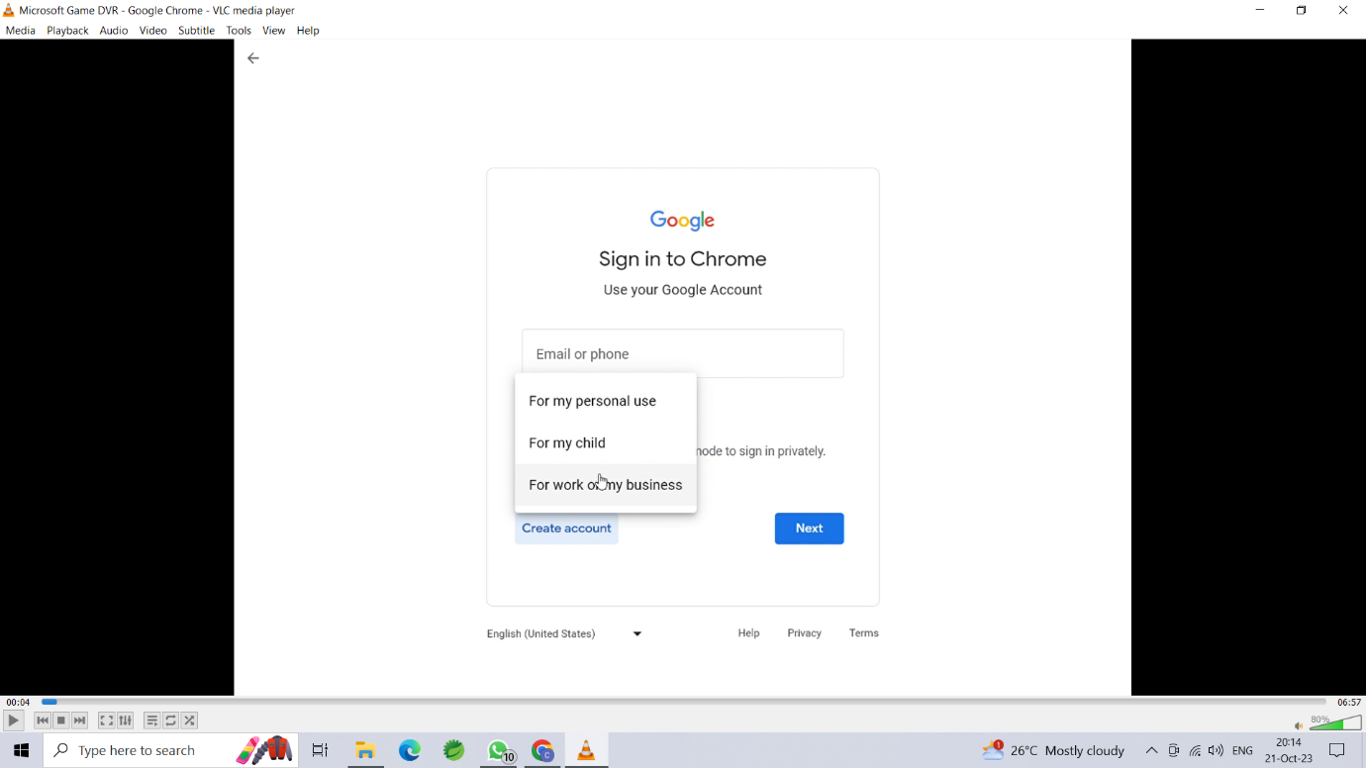

Step-4 Create an Instagram reel video using canva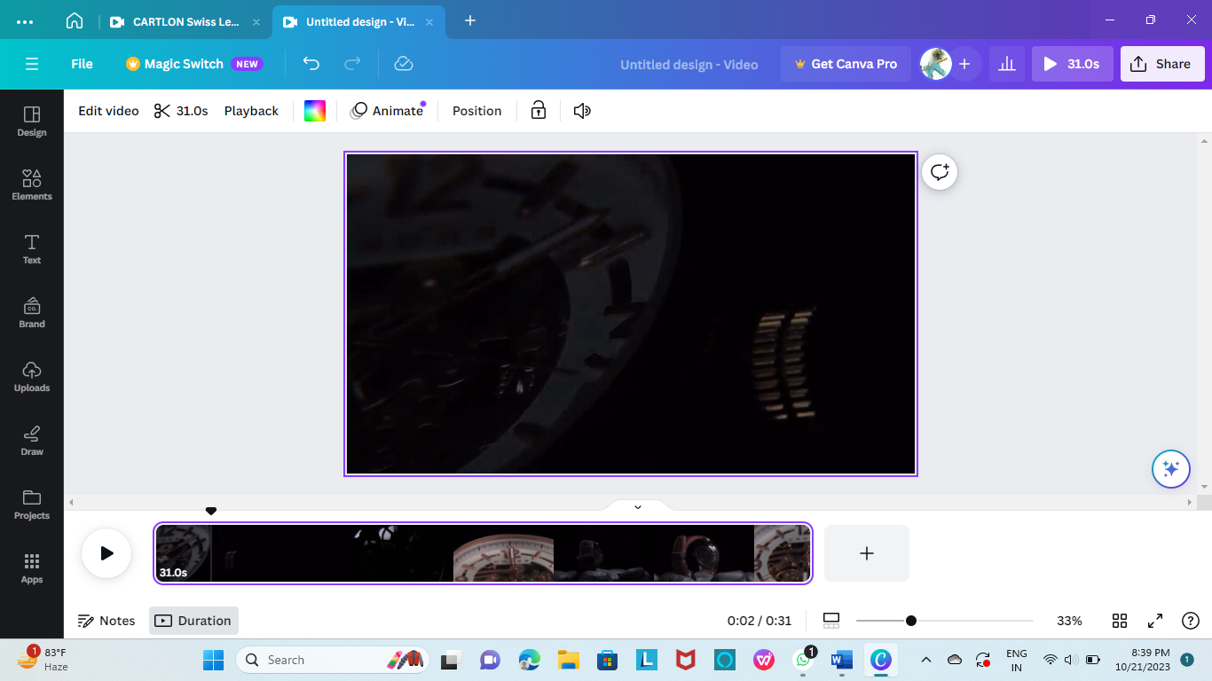

Step-5 Create an Instagram business profile for your brand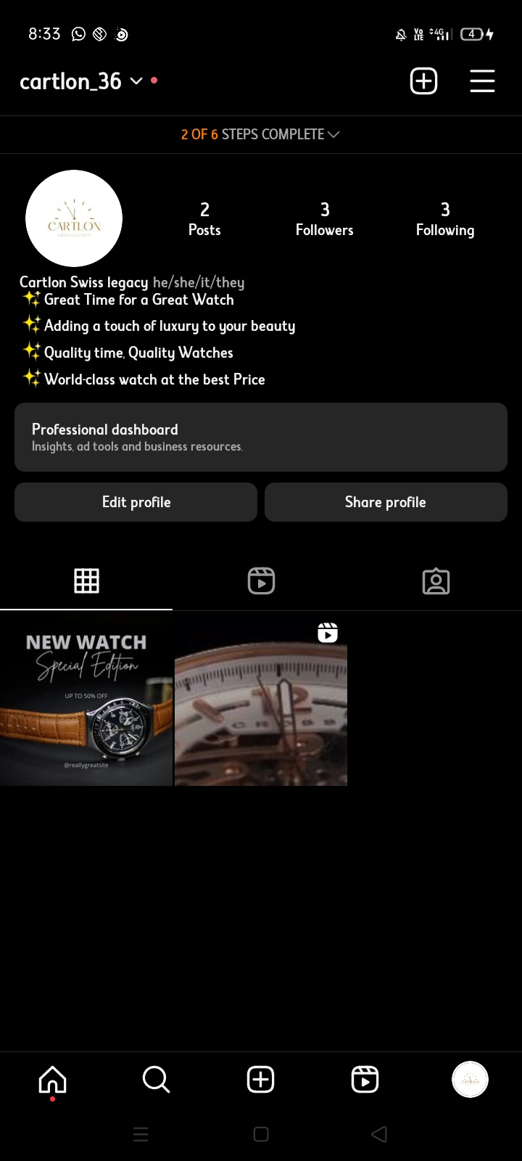

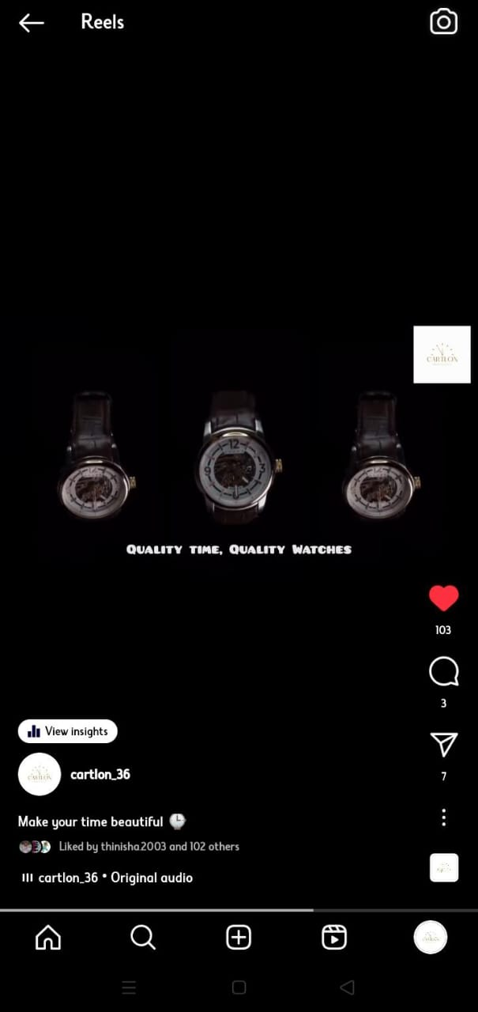

Link: <https://instagram.com/cartlon_36?igshid=NGVhN2U2NjQ0Yg==>

Video Link: <https://www.instagram.com/reel/Cypo21yLVz0/?igshid=M2MyMzgzODVlNw==>